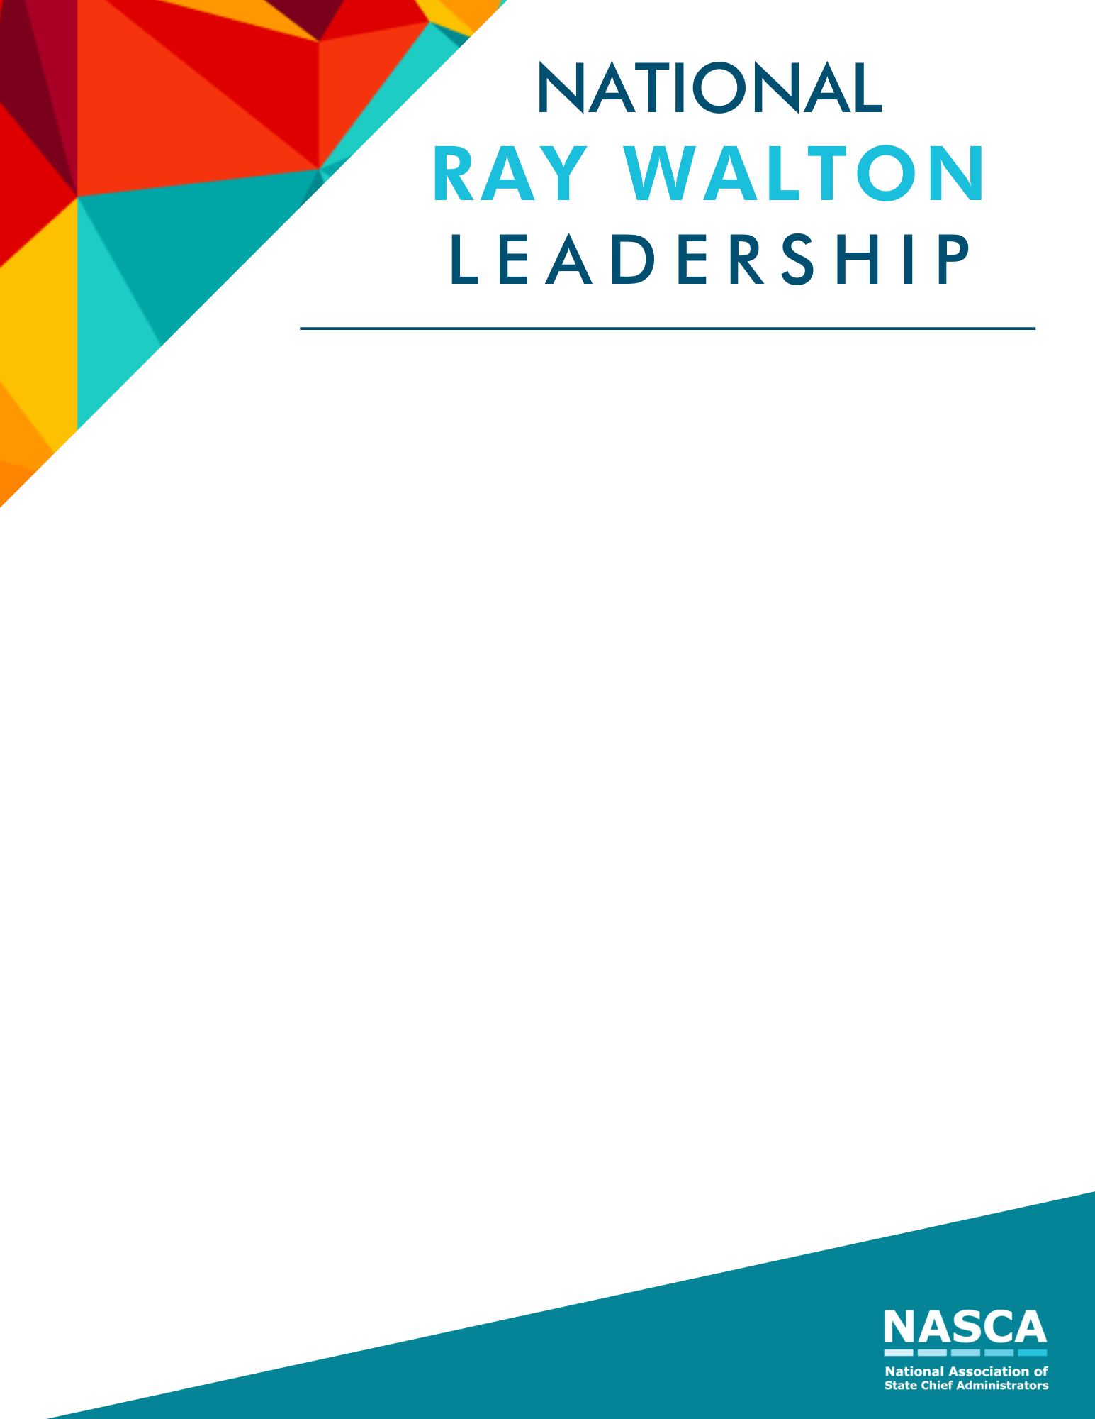

The National Walton Leadership Award was established to recognize State Chief Administrators for their passion, outstanding service, and commitment to state government operations. The award was created to honor Ray Walton for his long-term commitment and dedication to NASCA and state government. Being the former Executive Director for NASCA and former Director and Chief Operating Officer for the Iowa Department of Administrative Services, Mr. Walton’s legacy is paramount and gives direction for this award.
Eligibility: To be eligible for this award, the nominee must currently serve as a State Chief Administrator (or equivalent) or left the position no more than 12 months from date of submission. All NASCA members are eligible to nominate a CAO they feel exemplifies the award recognition. Nominees for this award must be current members of NASCA.
Criteria: Selection of the Walton Leadership Award honoree is based on two major criteria including accomplishments in his/her state along with service and leadership in the CAO role. Short submissions using bullet points are encouraged. If additional details are needed, NASCA staff will contact your office.
Nominee contact information:
Is the nominee currently serving as the State Chief Administrator (or equivalent)?
If no, did the nominee serve as a State Chief Administrator in the last 12 months?
Nominee’s Name:
Email:
Title:
Department:
State:

Submissions are limited to four pages in addition to the title page, although optional supporting material can be submitted as a separate document when needed to showcase images, examples, or documentation that is too large to fit within the five-page submission itself.
Visual aids are encouraged and may be included as supplemental material, but scores will be based on the written submission.
List accomplishments the nominee made in their state and/or for NASCA:

Provide details about their service and leadership in state government operations:

Other comments for the selection committee:

Submissions are due to NASCA no later than July 6, 2021.

