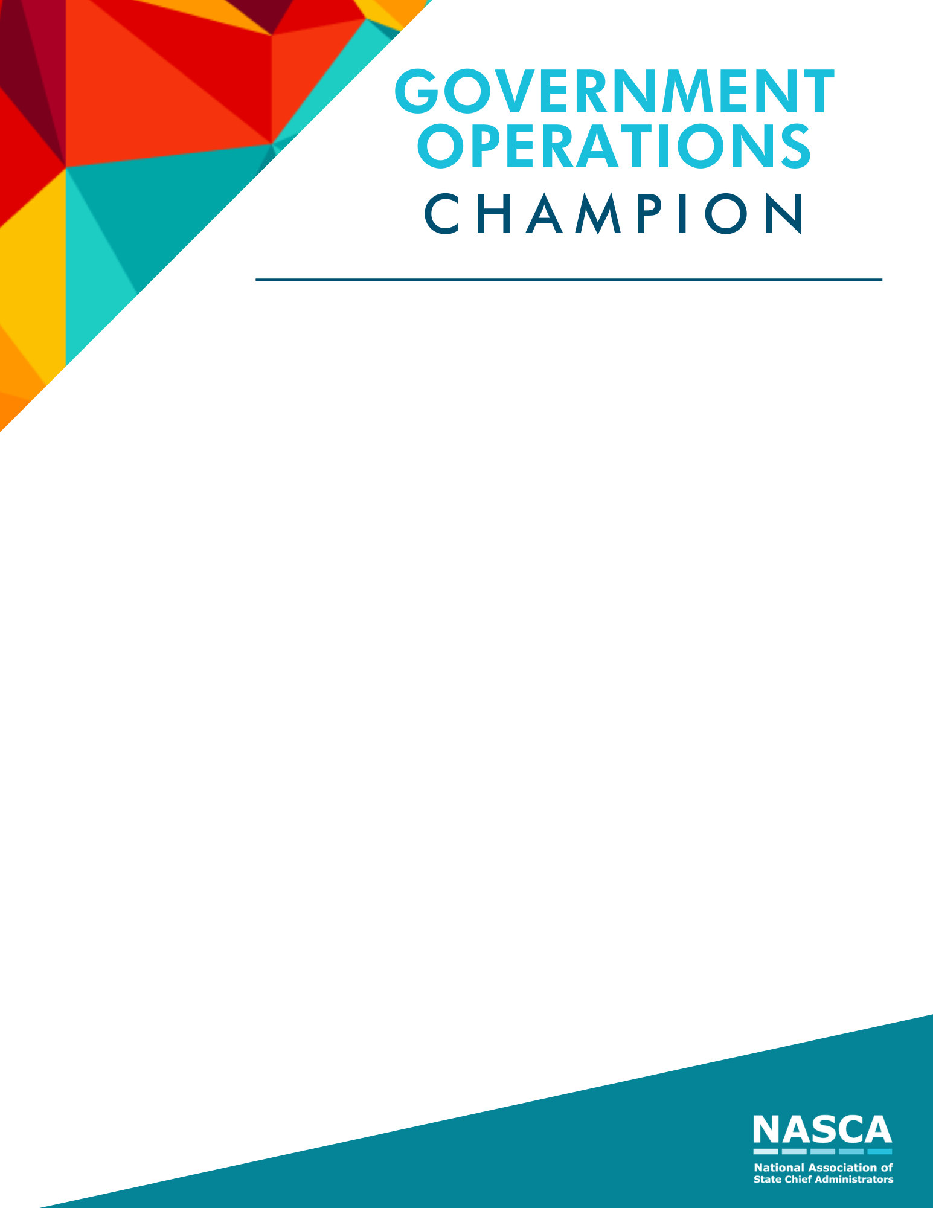

The Government Operations Champion Award shall be awarded to an individual that champions the critical role of efficient, effective, equitable operations and demonstrates a passion that good government operations and programs will enhance the customer and citizen experience. The nominee does not have to report to the chief administrator and may have worked significantly with the department of administration to advance the industry.
Eligibility: To be eligible for this award, the nominee must currently serve in state government or left the position no more than 12 months from date of submission. All NASCA members are eligible to nominate any state employee they feel exemplifies the award recognition. Nominees for this award must be from a state that is a current member of NASCA.
Criteria: Selection of the Government Operations Champion Award is based on two major criteria including accomplishments in his/her state along with service and leadership. This award is specifically for those who have contributed to the field of government operations. Short submissions using bullet points are encouraged. If additional details are needed, NASCA staff will contact your office.
Nominee contact information:
Is the nominee currently serving as the State Chief Administrator (or equivalent)?
If no, did the nominee serve as a State Chief Administrator in the last 12 months?
Nominee’s Name:
Email:
Title:
Department:
State:

Submissions are limited to four pages in addition to the title page, although optional supporting material can be submitted as a separate document when needed to showcase images, examples, or documentation that is too large to fit within the five-page submission itself.
Visual aids are encouraged and may be included as supplemental material, but scores will be based on the written submission.
List accomplishments the nominee made in their state

Provide details about their service and leadership in state government operations:

Other comments for the selection committee:

Submissions are due to NASCA no later than July 6, 2021.

