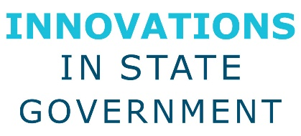
Innovations in State Government Award
Eligibility and Guidelines

- Programs/projects should have occurred within the last 24 months.

- Submissions must be made by State Chief Administrators (or equivalent) or other state member with the State Chief Administrators approval.

- State must be a member in good standing with NASCA.

- Projects submitted must be from one of the four categories: General Services, Infrastructure, Financial Management, Personnel.

- Only one nomination per state is allowed in each category.

- A project can only be nominated in one category, not multiple categories.

- Each state can win up to two recognition recipient awards per year. If a state has recipient-level ratings in more than two categories, the two highest scored categories will be chosen. In the other categories, the second highest score will be elevated to recipient and the original recipient will remain a finalist.

- At least one award will be given per category. A maximum of two awards will be given based on the score of the second highest rated project. If the second highest project is within 2 points of the highest project both will be recognized with an award.

- The projects must be result based. For example, each submission must be able to answer the following: What did the project seek to accomplish and how did the results justify the process? How did it create efficiencies and effectiveness in state government?

Categories:
General Services
Procurement
Fleet
Mail
Printing
Supplies

Infrastructure
Facilities
Construction
Information Technology
Telecommunication
Risk Management

Financial Management
Accounting
State Budget
State Insurance
Audit

Personnel
Human Resources
Professional Development Training

