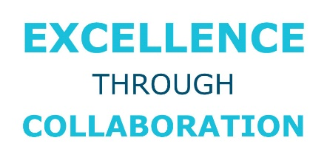
Excellence Through
Collaboration Award
Eligibility and Guidelines

- Programs/projects should have occurred within the last 24 months.

- Submissions must be made by State Chief Administrators (or equivalent) or other corporate partner with the State Chief Administrators written approval.

- State and corporate partners must be a member in good standing with NASCA.

- Collaborative partnerships submitted must deliver valuable public benefits, services, or resources that positively impacts the state’s citizens.
- The partnership must be outcomes-based and results-driven. For example, each submission must be able to answer the following: What did the collaborative partnership seek to accomplish and how did the results justify the process? How did it create efficiencies and effectiveness in state government?

- Nominated partnerships should focus on areas of priority for chief administrators with a citizen-centric focus such as general services, infrastructure, finance, and personnel. This would be considered a joint award to a state primary member and the corporate partner(s) that partnered in the project.

